Bio-Eagle



Biometrics
Time Attendance
&
Access Control

Directory

1. Introduction 3
1.1 Basic Concepts 4
1.1.1 User Enrollment 5
1.1.2 User Verification 5
1.1.3 Match Threshold Levels 5
1.1.4 User ID Numbers 6
1.1.5 Authority (status) Levels 6
1.1.6 Start-up window 7
2.1 How to place the finger 7
2. Enrollment and Verification Procedures 9
2.1 Enrolling Users 9
2.2 Testing an Enrollment 15
2.3 Enrolling a User with the Display Finger Option On 15
2.4 Verifying Your Identity 15
2.4.1 Start-up window 16
2.4.2 Password Verification 16
2.4.3 ID number & Fingerprint 17
2.5 Hints for Successful Enrollments 18
3. System Options 20
3.1 System Options 20
3.1.1 Date Time 21
3.1.2 Changing the Default Language 21
3.1.3 Advanced Options 21
3.2 Power Manager 22
3.3 Communication Option 23
3.4 Log Options 24
3.5 Access Options 24
3.6 Auto Test 25
4. Download fingerprints & AC Records 25
4.1 Install Attendance Management System 25
4.2 Connect PC and Bio-Eagle with RS232 26
4.3 Setup PC Com port rate:115200 or 9600 26
4.4 Connecting and Download AC Records 29
4.5 Upload staff's name to TAP-01 33
4.6 Connect PC and TAP-01 with TCP/IP 36
5. System Information 37
6. Trouble shooting 37

1. Introduction

This chapter shows the Bio-Eagle Fingerprint T&A basic concepts and how to place the finger.

Figure (Model: Bio-Eagle)

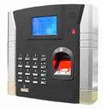

Figure (Model: Bio-Eagle) keypad

1 | 2 | 3 | ESC
4 | 5 | 6 | ▲
7 | 8 | 9 | ▼
◉ | 0 | OK | MENU

Keypad Definition

 Confirm the current present.
 Access to manage.
 Escape or cancel.
 Scroll up.
 Scroll down.
 Power button.
ˉˉ：Numerical key.

1.1 Basic Concepts
This section contains definitions and descriptions of Time Recorder Fingerprint T&A Concepts, including:
·User Enrollment
·User Verification
·Match Threshold Levels
·User ID Numbers
·Authority (Status) Levels
The two most important TimeClock Fingerprint T&A Functions are user enrollment and user verification.

1.1.1 User Enrollment
Enrollment is the process of create an ID number and scanning a user’s finger to create a template three times. This template is associated with a user ID number and stored.
During user verification, the stored template is compared to the current fingerprint scan to confirm the user’s identity.
Enrollment is performed at designated Time Recorder units. The user can verify on the time recorder that enroll his fingerprint. The enrollment process takes approximately 2 seconds.
Up to ten fingers can be enrolled for the same ID number, so the user may have more verifications way.
Ideally, everyone finger on each hand should be enrolled so that if the user injures the enrolled finger had, an alternate finger template is available. While recording the finger type is optional, it is recommended such as left or right index, so that at verification the user is prompted as to which finger to use.

1.1.2 User Verification
Verification occurs when a user either enters an ID number or places a finger in the fingerprint sensor, then input password for comparison with the stored template.

1.1.3 Match Threshold Levels
The Mach Threshold is a number that represents the degree to which verification is examined to ensure that the person is the person claimed.
The Match Threshold Levels establishes a balance between False Acceptance Rate (FAR) and False Rejection Rate (FRR). FAR measures how often a non-authorized user is falsely recognized and granted access to the system. FRR measures how often an enrolled and authorized user, who should be granted access to the system, is denied on the basis that the system did not recognize him.
You can set match threshold levels on a per-use basis. For the fingerprint verification is difficult, you can adopt ID & Fingerprint verification (match one to one).
Raising the threshold increases security, while lowering it increases throughout. The correct balance is essential.
For users with worn or damaged fingers, match threshold levels can (and should) be reduced.
Different sites have different requirements.

Table 1-1 Suggested Match Threshold Settings
FRR FAR One-to-many One-to-one
High Low 45 25
Middle Middle 35 15
Low High 25 10

1.1.4 User ID Numbers
Before beginning fingerprint enrollment, a user is assigned User ID Number. This ID number is used to call up the fingerprint template each time that verification is requested.
ID numbers are normally called up via the keypad, but they can be called up through other means such as RF Card.

1.1.5 Authority (status) Levels
TAS Clock Fingerprint T&A has four authority or status levels:
·Users are people whose identity must be verified, such to gain access to a facility or to have their attendance recorded.
·Managers can do other operations, except set advanced option and enroll manager’s authority.
Note: Without Manager status in the system, the Enroller will enroll them.

1.1.6 Start-up window
Click the power button and the screen showed on, a display of a window was called the Start-up window. The following appears:

Welcome

04-01-02 Thu

2.1 How to place the finger
1.The correct way is:
Place a finger flatwise on the sensor surface
Place it to the center of the sensor surface
2.When registering, please place finger on sensor surface for about 1 second.
3.If the quality of finger registry is very bad, please register another fingers to instead of.

Notice :
Correct Ways:
① The area of finger on the sensor surface should be larger.
② Place a finger flatwise on the sensor surface
③ Place finger to the center of the sensor surface

 | 

Incorrect Ways
 |  | 
①Touching | ②put on the left | ③Put on the right

 | 
④not straight | ⑤Put on the lower place

Note: Please adopt the correct way to place the finger; this company assumes no responsibility for errors from the use of the Time Recorder. This company reserves the right to revise document and to make changes from time to time in the contents here of without obligation to notify any person of such revision or changes.

2. Enrollment and Verification Procedures
This chapter describes how to enroll and verify users on the Fingerprint T&A verification system.
The following topics are included:
·Enrolling User
·Testing an Enrollment
·Enrolling a User with the Display Finger Option On
·Verifying Your Identity
·Hints for Successful Enrollments
Note: You must have Enroller, Manager, or Supervisor status to enroll users. For information on status levels, see “Authority (Status) Levels” on 1.1.5.

2.1 Enrolling Users
If this is the first enrollment in a new or empty system, everyone will become an enroller.
If there is a manager in the system, you will have Manager status to enroll a new user.
There are three ways of enrollment; fingerprint enrollment, password enrollment, fingerprint & password are suitable for three differences crowds. Fingerprint enrollment suited the most people who have better quality fingerprints; Fingerprint & Password suited few people who enrolling successful, but verification was difficult; Password enrollment suited 1% people who verification unsuccessful.
To start the enrollment process, identify yourself firstly-press [Menu], enter your ID number or fingerprint, and then verify your identity.
Note: If this is the first enrollment in a new or empty system, you will not be prompted for verification.
The following message appears on the display:
MENU
 User Manage
Option
Sys Info

Press [OK], access the User Manager, the following message display:
User Manage
Enroll User
Enroll Admin
Delete

Press [OK], access the User Enrollment, the following message display:

Enroll User
Enroll FP
Enroll Pwd
Fp & Pwd

Fingerprint Enrollment
- Access the Enroll Fingerprint to press [OK], the following display:

Enroll Fp

New Enroll？
ESC OK

(2) Press [OK], the following appears:
New Enroll

Enroll No. 00008
ESC OK

(3) Input the enrolling number (the range is 1 to 65534), press [OK], the following appears:

New Enroll

Place Finger……
ESC

(4) If the test is successful three times in a row, the following appears:
New Enroll

00008-1
ESC OK

Note: 00008-1

The last number 1 means the first fingerprint.
Press [OK], the previous message continues to be displayed while the template is created.
If your identity cannot be verified, you are prompted to try again. And you must restart the verification procedure (step 3).
2. Password Enrollment
(1) Access the password enrollment, press [OK], the following appears:

Enroll Pwd

New Enroll？
ESC OK

(2) Press [OK], the following appears:
New Enroll

Enroll No. 00008
ESC OK

(3) Input the enroll number (the range is 1 to 65534), press [OK], the following appears:

New Enroll

Input Pwd *****
ESC OK

Note: The password range is 1 to 5.
(4) Input the password, press [OK], the following appears:
New Enroll
Input Pwd *****
Pwd Affirm *****
ESC OK

(5) Input the password again, press [OK], the following appears:

New Enroll

00008-P
ESC OK

Note: 00008-P
The last letter P means password.

Press [OK], the previous message continues to be displayed while the template is created.
3.Fingerprint & Password
Access the Fingerprint& Password, press [OK], the following appears:

Fp & Pwd

New Enroll？
ESC OK

(2) Press [OK], the following appears:

New Enroll

Enroll No 00008
ESC OK

(3) Input the password (range is 1 to 65534), press [OK], the following appears:

New Enroll

Place Finger……
ESC

(4) If the test is successful three times in a row, the following appears:
New Enroll

Input Pwd *****
ESC OK

(5) Input your password, the following appears:

New Enroll
Input Pwd *****
Pwd Affirm *****
ESC OK

(6) Input the password again, press [OK], the following appears:
Note: 00008-1P
The second from the last 1 means one fingerprint
The last letter P means password.
New Enroll

00008-1P
ESC OK

Press [OK], the previous message continues to be displayed while the template is created.

2.2 Testing an Enrollment
Ask the users to place their finger to perform a test verification. If the test was successful, you will adopt Fingerprint enrollment. If the poor quality of fingerprint, you will be recommended to use Fingerprint & Password.

2.3 Enrolling a User with the Display Finger Option On
Press [ESC] to the Display Dinger Option On, the following appears:
Enroll Fp

New Enroll？
ESC OK
Backup Enroll

Enroll No 00008
ESC OK
ESC

Note: Where system memory permits, it is advisable to have at least two fingers enrolled for a long-term user.

2.4 Verifying Your Identity
The workers used Fingerprint T&A to verify their identity. The system defaults to three ways of verification: Fingerprint verification, Password verification, ID number & Fingerprint. The following appears

2.4.1 Start-up window
Place the finger on the sensor surface, the following appears:

Fp Verify

Pls. Move finger

It continues for about 0.5 seconds. If the test is successful, it will say “Thank you”, the following appears:
Fp Verify

Enroll No 00008
Verified！

If your identity cannot be verified, you are prompted to try again, the following appears:
.
Fp Verify

Place finger Agn！

It continues for about 0.5 seconds, return to the start-up window.

2.4.2 Password Verification
To start the enrollment process, enter your ID number, the following appears:

1：1 Fp Match

Enroll No 0008
ESC OK

Press [OK], the following appears:
Pwd Affirm

Enroll No 0008
Input Pwd *****

Input correct password, press [OK], the following appears:
Pwd Affirm

Enroll No 0008
Verfied

If the password cannot be verified, the following appears:
Pwd Affirm

Enroll No 0008
Error Pwd.！

2.4.3 ID number & Fingerprint
To start the enrollment process, enter your ID number, the following appears:

1：1 Fp Match

Enroll No 0008
ESC OK

If your identity is verified, the following appears:
1：1 Fp Match

Enroll No 00008
Verified！

2.5 Hints for Successful Enrollments
The fingerprint is of good quality, the verification speed will fast; otherwise, it will verify slowly or occur to FRR.
In order to improve the fingerprint verification quality, the following hint appears:
Table 2-1 Enrolled unsuccessful or the fingerprint of poor quality

Dry or dirty fingerprints | Solve the dry problems that rub the dry finger and palm.  If the fingerprint is dry, you will adopt the way of wetting up the finger, such as rub the forehead
Have no enough to bring pressure | The user should place a finger firmly and squarely on the sensor surface.
How to select the finger? | Recommend to left or right index or middle finger. Use fingerprints of good quality, without worn or hurt. The user usually selects the forefinger, if it was of a poor quality, you will be recommended to middle finger or ring finger.
How to place the finger? | Place your finger firmly and touch the sensor surface must be over 2/3. The fingerprint does not touch upright on the sensor surface. Do not touch the finger too fast;  Do not move the finger on the sensor surface
The influence of the fingerprints change | For users with worn or damaged fingers, the identification  can be influenced. If the finger quality was poor, you will select password verification.
Others | However, few people’s fingerprint quality is too poor to verify the fingerprint in gear. Please use ID &  Fingerprint verification, and the Match Threshold  Levels can be reduced or use password verification.

3. System Options
Press the [Menu], then verify your identity. The following appears:
MENU
User Manage
Option
Sys Info

Access Options, press [OK], the following appears:
Option ▼
System Opt
Power Mng
Comm Opt

The following topics included: System Options, Power Manage, Communication Options, Log Options and Auto Test.

3.1 System Options

Access System Opt, the following appears:

System Opt ▼
Date Time
Language Sch
Lock 254

The setup facility covers four areas: System Options, Language, Lock and Advanced Options.

3.1.1 Date Time
Access Date Time, the following appears:
Date Time
2004-01-02
08:24:35
ESC OK

To change the date, press and , then input the correct date and time, press [OK]

3.1.2 Changing the Default Language
Access Language, press [OK], it defaults to SCH. Press to select another language. Fingerprint T&A comes with three built-in languages, simplified Chinese, traditional Chinese, and English for all displays. Select the language that you will use, press [OK], then Press [ESC] to return the Options. The system will ask for confirmation of the displayed language. Press [OK] to accept the language displayed.

3.1.3 Advanced Options

Access Advanced Option, press [OK], the following appears:

Adv Option ▼
Restore Default
Clear all Data
Delete Logs

Press and to scroll up or down the screen to select the option.
Restore Default: restore all setup information to default.
Clear all Data: delete all enrolling fingerprints and logs.
Delete Logs: delete all logs of flash disk.
Clear Managers’ rights: change the managers’ rights into ordinary users’ rights.
Show Score: whether show the quality value of fingerprint in the screen or not;
Match Threshold Levels: For helping in selecting threshold level settings, see Table 1.1.3.
Sound: whether use to phonic hint or not.

3.2 Power Manager
Access Power Manage, the following appears:

Power Mng ▼
ShutDown No
Power On No
Sleep No

Power Mng ▲
Sleep No
Idle No
Idle Min 0

This product uses smart manage system, supports the time switch and resting features, it can satisfy the user’s different demands.
Shutdown: auto shut-off in the timed.
Power on: auto open-up in the timed.
Sleep: automatic resting in the timed, press any key to enter working state.
Idle and Idle Minute, they are related each other, while the idle minute is zero, the idle is closed; while the idle minute is not zero (unit was minute), for example, it is one minute, the user does not do anything in one minute, the system will enter the idle state.
Select Shutdown, press [OK], the following appears:
ShutDown

Set OnTime Fun？
ESC OK

Press [OK], then enter Shutdown, press [ESC] to cancel.

3.3 Communication Option
Access Comm Opt, the following message appears:

Comm Opt ▼
Dev Num １
BaudRate 115200
IP Addr
Comm Opt ▲
Enthrnet No
RS232 Yes
RS485 Yes

Time Recorder Fingerprint T&A support RS232, RS485, TCP/IP, whether you use Single-Board Computer (SBC) or Networking, Bio-Eagle will satisfy the user’s demands.
Device Number: machine ID; the range is 1 to 255.
Baud Rate: there are three options, 9600, 38400, 115200; the speed of communication is fast, recommend to use RS232; the speed of low communication is stable, recommend to use RS485.
IP address: it defaults to IP address is 192.168.1.201.
Net Speed: Auto is recommended..
Ethernet: whether use TCP/IP protocol or not.
RS232: communication is RS232.
RS485: communication is RS485.
COMM Key: when connecting with PC, if there is a comm. Key, you need to key in it., if there is not a comm. Key, you just left the blank empty.

3.4 Log Options
Access Log Opt, the following message appears:

Log Opt
Alm Attlog 1
ReCheck Min 0

Alarm Attendance Log: when the remainder log capacity reached set numerical value, it will automatically sound a warning that logs were fulled.
Recheck Minute: Set within compass (Unit: minute). Someone’s enrollment has enrolled, then, the log twice was not displayed in the system.

3.5 Access Options
1.Define TZ
2.User Acc Opts
3.GRP TZ Define
4.Access Comb
5.Lock

3.6 Auto Test
Access auto test, the following message appears:

Auto Test ▼
Run All Test
FLASH Test
LCD Test
Auto Test ▲
Fp Reader
Key Test
RTC Test

In the option, you can run system device test. When the device broken down, it can analyze the cause of the device’s fault and the devices were quickly and easily maintained.
It tests the Memory, LCD, Sound, Fingerprint sensor, keypad and clock. In the course of test, you should guarantee the stability of the power. Otherwise, the system’s hardware was probably damaged; especially it runs the memory test.

4. Download fingerprints & AC Records
1.Install Attendance Management System
2.Connect PC and TAP-01 with RS232
3.Setup PC COM port rate: 115200
4.Connecting and Download AC Records
5.Upload staff's name to TAP-01

4.1 Install Attendance Management System
Insert Disk to CD Rom and start setup procedure and complete it.(if there are any update program, please execute it, too)

4.2 Connect PC and Bio-Eagle with RS232
Make sure the switch of controller is pointed at RS232/RS485
The communication for TAP-01 is RS232
“Menu”->”Option”→”Comm. Opt”→”RS232”→”Yes”
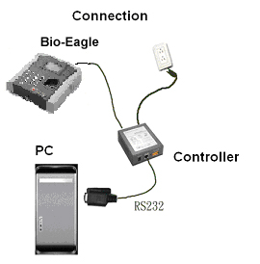
Connect PC and Bio-Eagle with RS485

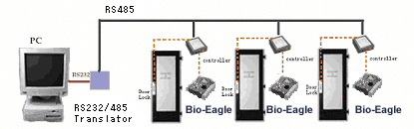

4.3 Setup PC Com port rate: 115200 or 9600
if connected with RS232, 115200 is recommended, if with RS485, 9600 is recommended

(1)
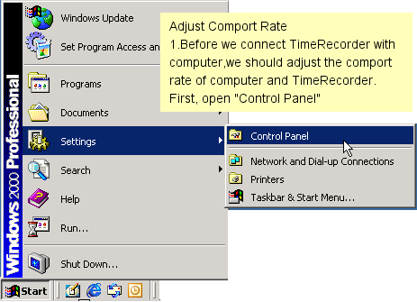
(2)
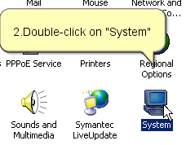

(3)
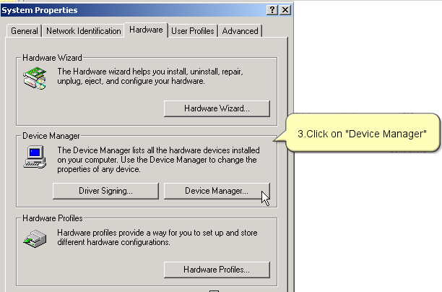
(4)
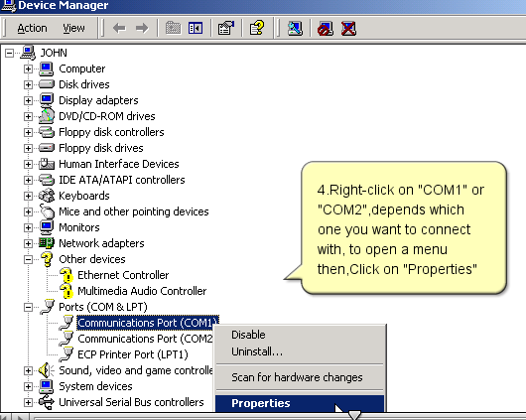

(5)
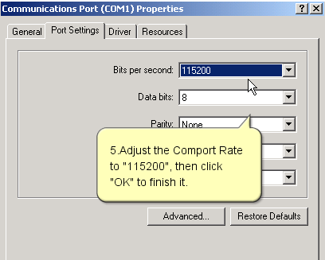

4.4 Connecting and Download AC Records
(1)Double-click on shortcut on desktop


(2)Active this product
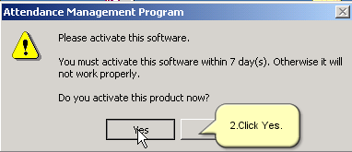
(3)Click “Yes”
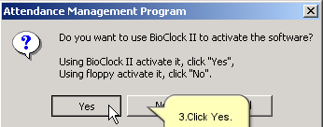

(4)Make sure settings are correct, then click “Connect”
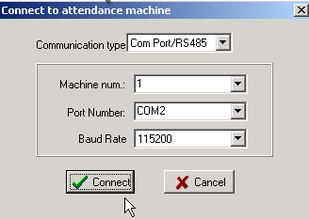

(5)Product active succeed
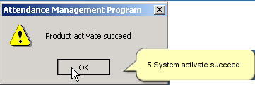
(6)Enter “Time Recorder Communication”, and again just do the same like step 4
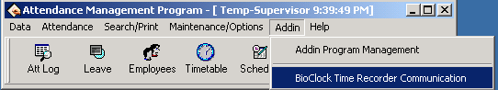

(7) Check “Download user Info”, then click “Execute” button to download User name and password.
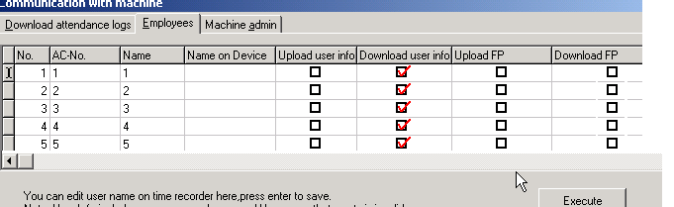

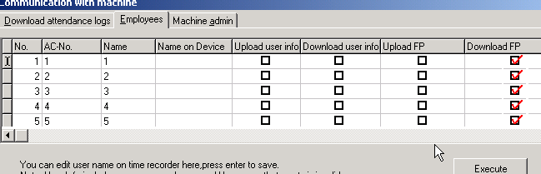
(8) Check “Download Fp”, then click “Execute” button.

(9)Click “Download all records” to download A.C. Records.
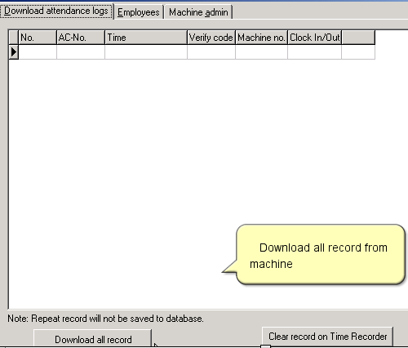

(10)Download successfully
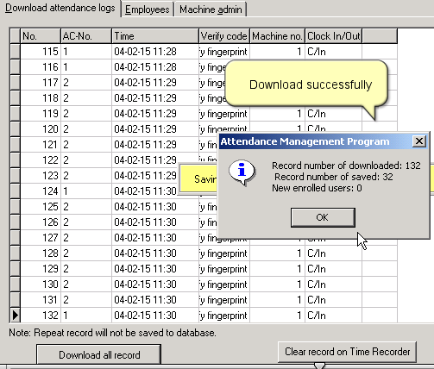

4.5 Upload staff's name to Bio-Eagle
(1)Enter “Employee Maintenance”
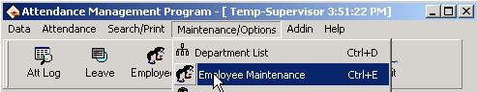

(2)Input Names, then out of this window
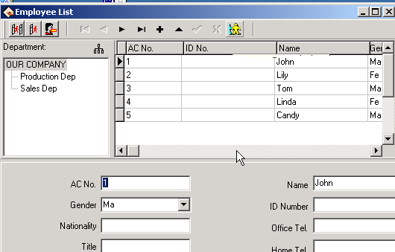
(3)Enter “Time Recorder Communication”

(4) Click “Connect”
(5) Check “Upload user info”, then click “Execute” to upload name and password.
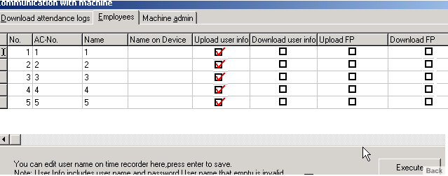

(6)Names have been uploaded to Machine successfully. If you need to upload fingerprints to another m/c, please check the column of “Upload FP’, then click on “Execute” button.
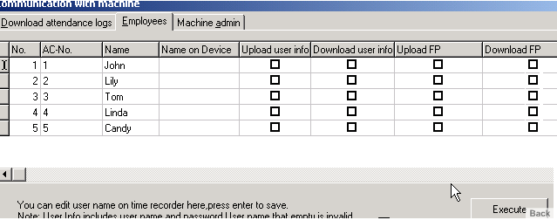

4.6 Connect PC and Bio-Eagle with TCP/IP

Connect PC and Bio-Eagle with TCP/IP

1.Make sure the switch of controller is pointed at TCP/IP
2.The communication for TAP-01 is TCP/IP
“Menu”->”Options”→”Comm Opt”→” IP Addr”→”213.10.15.124”(use fixed IP address.
“Menu”->”Options”→”CommOpt”→”Ethernet”→”Yes”
“Menu”->”Options”→”Comm Opt”→”RS232”→”No”
“Menu”->”Options”→”Comm Opt”→”RS485”→”No”
“Menu”->”Options”→”CommOpt”→”NetSpeed”→”Auto”
The download and upload procedure, please reference chapter 4.1， 4.3 ，4.4， 4.5.
Note: If the controller box is reset, please restart the box by pulling off the wire, if reset the comm. Options, please restart the Bio-Eagle.

5. System Information
Access [Menu] to Sys Info, press [OK], the following appears:

Sys Info ▼
User Cnt 206
Fp Cnt 173
Att Log 8046
Sys Info ◆
Admin Cnt 0
Pwd User 37
Res Space

Sys Info ▲
Pwd User 37
Res Space
Dev Info

It displays user numbers, password numbers, fingerprint numbers, manager and log numbers in the screen. You can see some information such as the remainder log capacity in the memory; the device capacity, the defaults date; machine number and OEM’s information are in the system.

6. Trouble shooting

1. Cleaning
From time to time, the optical platen, the keypad and display window require cleaning. Since working environments differ, it is not possible to define when cleaning should be performed. Following is guide:
Table 5-1 Cleaning Schedule
Item | Cleaning Frequency
Keypad and display window | Cleaning when visibly dirty and hard to read. See cleaning the keypad and  Display below.
Optical platen | Do not over clean. The platen is designed to work under greasy or dirty conditions.
However, do clean if the platen is
Obstructed or people are reporting deteriorating
Performance. See cleaning the Optical Platen below.

2. Cleaning the Keypad and Display
To clean the keypad and display, use the same cleaning products as for the platen, and wipe dry.
3. Cleaning the Optical Platen
Clean the optical platen as follows:
(1) If dusty or gritty, first blow on the platen to clean off any loose particles.
Spray on a light coating of a window cleaning product or other similar neutral detergent.
Warning: Do not use any other cleaner or the platen may become damaged.
(3) Using a non-abrasive and intone, pat dry. Be careful not to scratch the platen. If lint particles adhere to the platen surface, below them off when the platen is dry.

User Manual

